Sequence Specification Document

Customer Registration Sequence
Purpose
The Customer Registration Sequence Diagram illustrates the interaction between system components for the KriGo platform user account registration process. This diagram shows how the communication works for the creation of a new customer account between the user interface, business logic components, and data storage layer to ensure data validation and system integrity.
The sequence diagram shows the whole process of registration including input validation, checking for duplicate accounts, creating a customer account and handling exceptions.
Participating Objects
The sequence diagram involves the following participants:
- Guest (Actor): Represents a user who has not yet created an account and wishes to register on the platform.
- RegistrationUI (Boundary): Provides the registration interface and manages user interactions.
- AuthController (Control): Coordinates the registration process and executes business logic.
- ValidationService (Control): Validates the information provided by the user.
- CustomerRepository (Entity): Manages customer data persistence operations.
- Customer (Entity): Represents the customer entity being created.
- Database (Database): Stores customer account information.
Registration Process
A guest user starts the registration process by opening the registration page from the RegistrationUI. The system shows the registration form where the user can fill in personal information, such as name, email address, password, phone number and other required information.
When the user submits the registration form, the RegistrationUI submits the registration request to the AuthController. The controller will call the ValidationService to validate the submitted information for correctness and completeness.
If the validation passes, the AuthController then checks the CustomerRepository to see if the email address supplied is already in the system. If the email address is unique the controller proceeds to create a new customer account and stores the customer information in the database.
Once the account is successfully created, the system will send a message to the user confirming that the registration process has been completed successfully.
User Information Validation
Before creating a customer account, the system performs several validation checks to ensure data integrity and security. These validations may include:
- Verification of mandatory fields.
- Validation of email address format.
- Password strength verification.
- Validation of phone number format.
- Consistency and completeness checks.
If any validation rule fails, the ValidationService returns the corresponding error information to the AuthController, which requests the user to correct the invalid data before proceeding.
Duplicate Account Verification
The sequence diagram depicts a verification process to make sure duplicate customer accounts are not created. The AuthController checks the CustomerRepository to see if the email address entered has already been saved in the database.
In case the system finds an existing account, the registration process is aborted and an error message is sent to the user, informing that the email address is already registered.
This validation process verifies the uniqueness of customer accounts and maintains the integrity of data.
Alternative and Exceptional Flows
The Customer Registration Sequence Diagram incorporates several alternative scenarios to handle exceptional situations:
- Invalid or incomplete registration information.
- Email address already associated with an existing account.
- Failure during account creation or database operations.
These alternative execution paths ensure that the registration process remains reliable, secure, and user-friendly.
Security Considerations
The registration process includes several security measures to safeguard user information and uphold the platform's integrity. This includes input validation, duplicate account detection, secure password management, and controlled access to customer data.
The system mitigates the risk of invalid registrations and unauthorized access by implementing this validation and verification mechanism.
Conclusion
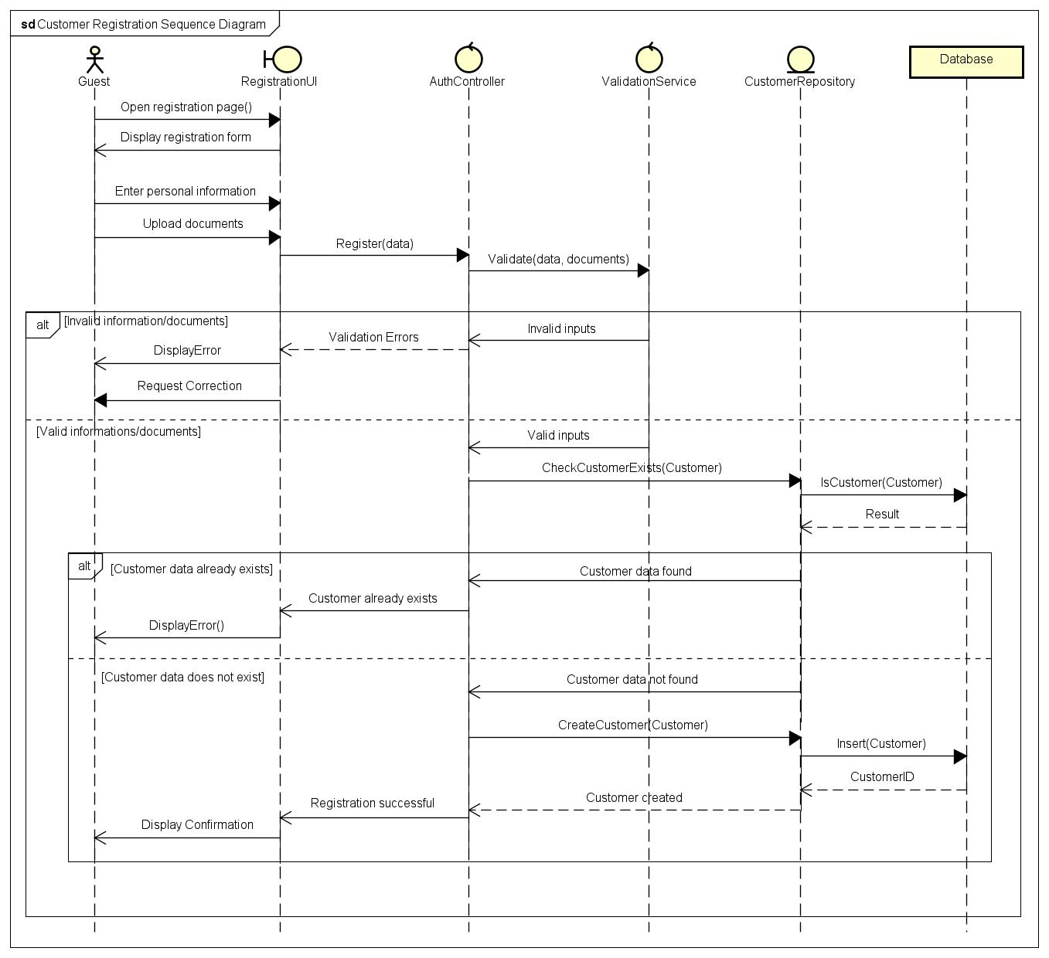
The Customer Registration Sequence Diagram describes the process of account creation in KriGo platform in detail. It is a reference diagram of the relationships between presentation, business logic, validation and data persistence layers with a focus on data validation, account verification and exception handling. This diagram is a base design artifact to understand the customer onboarding process and validate the registration requirements of the platform.
Figure 1 - Customer Registration Sequence Diagram

Vehicle Search & Discovery Sequence
Purpose
Vehicle Search & Discovery Sequence Diagram represents the interaction between users and the system components in the vehicle search and comparison process acquired through KriGo platform.
This sequence diagram shows the movement of activities in vehicle discovery subsystem in the sense that user requests will have to pass through the user interface, business logic layer and database layer.
The sequence diagram models basic process of searching and finding vehicles also includes special operations of filtering the search and comparison of various vehicles.
Participating Objects
The sequence diagram involves the following participants:
- User (Actor): Initiates vehicle search and discovery operations.
- SearchUI (Boundary): Provides the user interface for entering search criteria and displaying search results.
- VehicleSearchController (Control): Coordinates the search process and manages business logic.
- SearchService (Control): Validates search criteria and processes search operations.
- VehicleRepository (Entity): Retrieves vehicle information from the data storage layer.
- Database (Database): Stores vehicle records and related information.
- MapService (External Service): Provides location-based services when geographical filtering is required.
Vehicle Search Process
Once the user initiates the search by opening the search form and providing the required search parameters, like vehicle type, location, rental period, price and so on, the SearchUI sends the request to the VehicleSearchController that supervises the process.
The VehicleSearchController checks if the parameters entered are correct and valid using the SearchService. If they are indeed valid, the SearchService sends a request to the VehicleRepository in order to get the data.
Then the VehicleRepository retrieves information about the vehicles that comply with the conditions set by the user.
Search Criteria Validation
Before performing a query request, the system proceeds to verify search parameters for correctness and completeness. Validation process consists of checking date ranges, location data, and other input fields deemed mandatory. If the input data provided is incorrect, the system provides the necessary feedback for correction.
No Results Scenario
The sequence diagram demonstrates an alternate path of execution of the sequence, which describes the scenario in which no vehicles matched the requirements of the user. In this case, the VehicleRepository gives an empty dataset to VehicleSearchController. The system notifies the users that there is no vehicle that fits the description and may give an idea on how to change the search parameters.
Vehicle Filtering Process
After the result set of vehicles is displayed to the user, there is an opportunity to further filter the vehicles. There are many ways to filter the database, such as by vehicle type, transmission, fuel type, number of seats, price range, ratings, and the availability of the vehicles. When the filters are applied, the filtering request is forwarded to VehicleSearchController, which processes it through the VehicleRepository. The database then returns the dataset that corresponds to the filtering.
Vehicle Comparison Process
The vehicle comparison feature has also been modeled in the sequence diagram. The user will be able to choose many vehicles and request comparison information. The SearchUI sends the request to compare the vehicles to the VehicleSearchController, which gets all the necessary information from the VehicleRepository for the chosen vehicles. After the information has been retrieved from the database, it is transformed into a comparison view in which the chosen vehicles are shown one next to another for comparison. Thus, users will be able to compare different cars according to the parameters such as price, type of the car, fuel consumption, number of seats, type of transmission, reviews, and more.
Alternative and Exceptional Flows
The sequence diagram incorporates several alternative scenarios to ensure robust system behavior:
- Invalid search criteria entered by the user.
- No vehicles matching the specified search conditions.
- Application of additional search filters.
- Comparison of multiple selected vehicles.
These alternative flows improve system usability by providing meaningful feedback and supporting flexible search behavior.

Conclusion
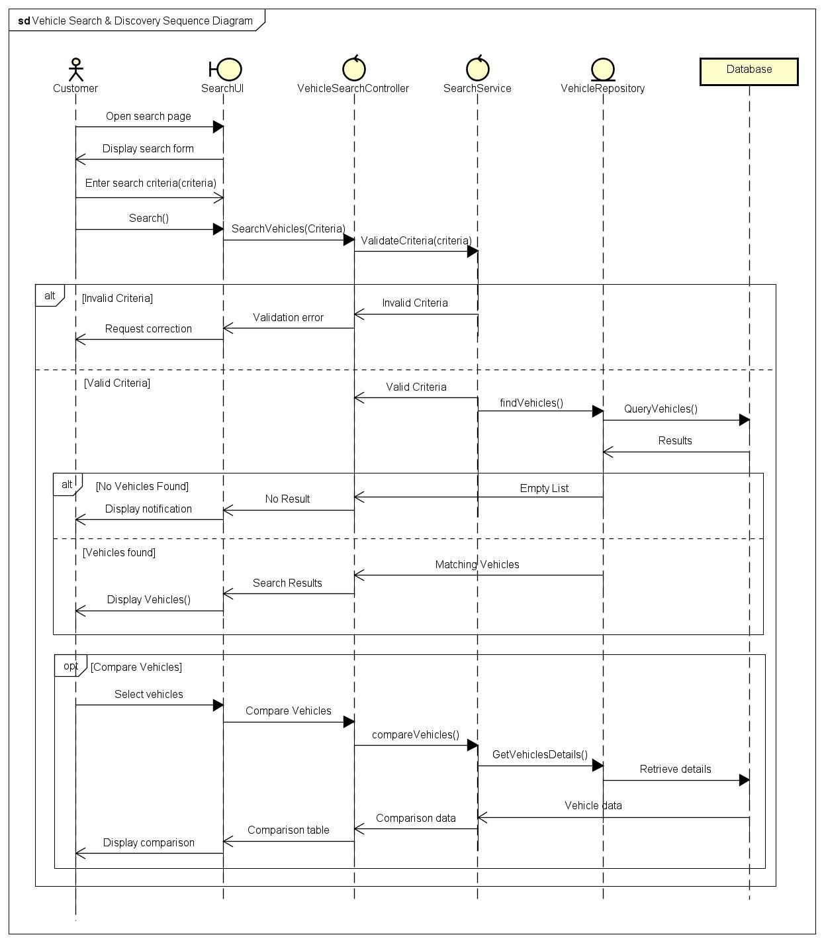
The Vehicle Search and Discovery Sequence Diagram illustrates all the interactions happening to find, filter, and compare vehicles through the KriGo application. Furthermore, the diagram shows how the application layers work together, which include presentation layer, business logic layer, and data access layer. Moreover, the diagram emphasizes the importance of input validation, data retrieval, filtering process as well as vehicle comparison.
Figure 2 - Vehicle Search & Discovery Sequence Diagram

Reservation Management Sequence
Purpose
The Reservation Management Sequence Diagram provides a dynamic representation of the way the involved parties within the KriGo system interact with each other. The Reservation Management Sequence Diagram offers a business conceptualization of how the system functions with respect to vehicle reservations. The diagram illustrates the process of making, reviewing, modifying, and canceling reservations.
Participating Objects
The sequence diagram includes the following participants:
- Customer (Actor): Initiates reservation-related operations.
- ReservationUI (Boundary): Provides the user interface for reservation management.
- ReservationController (Control): Coordinates the reservation workflow and business logic.
- AvailabilityService (Control): Verifies vehicle availability and validates reservation constraints.
- ReservationRepository (Entity): Manages reservation persistence operations.
- VehicleRepository (Entity): Provides access to vehicle-related information.
- Database (Database): Stores reservation and vehicle data.
- Rental agency (External Actor): Receives notifications regarding reservation cancellations.
Reservation Creation Process
The reservation operation starts with the choice of the vehicle and the start of the reservation process.
At this point, the customers will have access to a reservation form where they will be able to enter their reservation specifics.
After the customer has approved the reservation request, the system's Reservation Controller calls upon the Availability Service to ascertain whether the vehicle is free for the rental days specified by the customer.
In case the vehicle is free at the date and time chosen by the customer, the Reservation Controller will register the reservation in the Reservation Repository, which takes care of saving the reservation information in the database.
The system will then provide confirmation of the reservation and notify the customer about the specifics of the reservation. In case the vehicle turns out to be fully booked, the reservation will not be processed, but the system will offer the customer information regarding other available options.
Reservation Status Viewing
The sequence diagram also describes the procedure for checking the status of hospitable room reservations.
Whenever a customer wishes to review reservation details, he/she sends the request to the online Reservation Controller, through which queries regarding the reservation details of the customer are raised to the Reservation Repository and the related information is retrieved by querying the database available.
The whole information becomes visible to the customer as the Reservation Controller displays it for him.
Reservation Cancellation Process
The cancellation process starts when a customer requests to cancel an existing reservation.
The Reservation Controller verifies whether the reservation conforms to the cancellation policy requirements. If cancellation is done, the Reservation Repository shall put the reservation in the database, notifying the corresponding rental agency of the cancellation.
Finally, the customer receives confirmation of a successful cancellation.
When the cancellation policy does not allow cancellation, the system refuses the request and gives a suitable notification message to the customer.
Reservation Modification Process
Furthermore, the sequence diagram illustrates the modification process.
When a customer applies to change a booking, the Reservation Controller will verify the required changes through the Availability service.
If the vehicle and the dates chosen by the customer are available, the Reservation Repository will be able to update the booking information in the database and provide confirmation related to the changes made.
Otherwise, if the modifications could not be accommodated due to vehicle unavailability, the customer will be informed about the situation by the system.
Alternative and Exceptional Flows
The sequence diagram incorporates several alternative execution paths to represent exceptional situations:
- Vehicle unavailable during reservation creation.
- Invalid reservation information entered by the customer.
- Cancellation requests rejected due to policy restrictions.
- Vehicle unavailability during reservation modification.
These alternative flows ensure that the system maintains data consistency while providing appropriate feedback to the customer.
Conclusion
The Reservation Management Sequence Diagram illustrates the full cycle of reservations within KriGo, including the interaction between the UI components, business logic controllers, repositories, and outside actors. Additionally, it reveals the importance of validation, checking the availability of the reservations, assuring the persistence of the necessary data, as well as handling any possible exceptions.

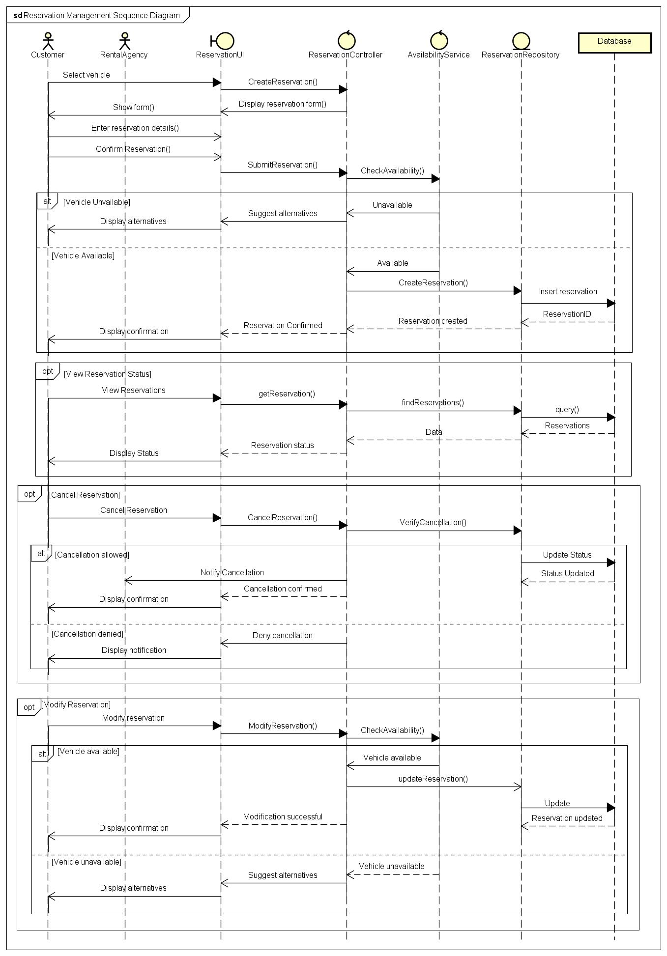
Figure 3 - Reservation Management Sequence Diagram

Payment Processing Sequence
Purpose
The Payment Processing Sequence Diagram illustrates the interactions between the customer, the payment subsystem and external payment services for the payment process in the KriGo platform. This diagram shows the steps needed to securely process a reservation payment, verify the transaction, communicate with the payment gateway, and update reservation records and notify the customer of the transaction.
The sequence diagram depicts the successful and unsuccessful cases of the payment and also the secure handling of the transactions and data consistency.
Participating Objects
The sequence diagram includes the following participants:
- Customer (Actor): Initiates the payment for a confirmed reservation.
- PaymentUI (Boundary): Provides the payment interface and collects payment information.
- PaymentController (Control): Coordinates the payment workflow and manages business logic.
- PaymentService (Control): Validates payment details and communicates with the external payment provider.
- PaymentGateway (External System): Processes electronic payment transactions and returns the payment result.
- ReservationRepository (Entity): Updates the reservation status after payment processing.
- PaymentRepository (Entity): Stores payment transaction records.
- Database (Database): Persists payment and reservation information.
Payment Processing Workflow
When the customer chooses a confirmed reservation and chooses to pay, the payment process is started. The PaymentUI shows the payment form where the customer can enter the required payment details, including the selected payment method and transaction details.
Once the payment request has been submitted, the PaymentController will use the PaymentService to validate the payment information. When the payment details are valid, the PaymentService submits the transaction request for authorization to the external Payment Gateway.
Once the transaction is done, the PaymentGateway passes the payment result back to the PaymentService. If the payment was successful, PaymentController saves the transaction using PaymentRepository, changes the reservation status to Paid using ReservationRepository and displays a payment confirmation message to the customer.
Payment Validation
Before the payment data is handed over to an external payment provider, the system runs through a couple of validation steps to make sure that the data provided is correct and complete. These validations include fields necessary for payment, supported payment methods, consistency of transaction amount, and eligibility for reservation.
If any validation rule is not satisfied, the payment process is interrupted and the customer is asked to correct the data provided before resubmitting the payment request.
Successful Payment
After receiving the go-ahead from the external PaymentGateway, the system records the payment data in the database and updates the corresponding reservation status. The customer then receives a confirmation message with the payment reference and transaction status.
This process allows payment records and reservation information to remain in sync in the system.
Failed Payment
The sequence diagram also models scenarios where the payment cannot be performed. Possible reasons for transaction failure include insufficient funds, incorrect payment credentials, network communication problems, or rejection by the payment gateway.
If there’s an error, the PaymentGateway will send an error response back to the PaymentService. The PaymentController notifies the customer that the transaction was unsuccessful and keeps the reservation in the same state as before. The customer can then try to process the payment again using the same or different payment method.
Alternative and Exceptional Flows
The Payment Processing Sequence Diagram includes several alternative execution paths to improve system reliability:
- Invalid or incomplete payment information.
- Payment authorization rejected by the external payment gateway.
- Communication failure with the payment provider.
- Successful payment resulting in reservation confirmation and transaction recording.
These alternative scenarios ensure that the system maintains transactional integrity while providing clear feedback to users throughout the payment process.
Security Considerations
The payment subsystem has various security features to guarantee the safety of financial transactions and customer data. Payment details are verified before processing. Communication with the external payment gateway is performed over secure channels and only transaction results are stored within the platform. No sensitive payment credentials are stored permanently in the application database.
These measures help to ensure confidentiality, integrity and reliability in the payment process.

Conclusion
The Payment Processing Sequence Diagram details the payment workflow in the KriGo platform in a comprehensive manner. It illustrates the interplay of presentation layer, business logic, data repositories and external payment services and emphasizes on payment validation, transaction authorization, reservation updates and exception handling. This diagram is an important design artifact for understanding the payment sub-system and for validating the functional requirements related to secure online transactions.
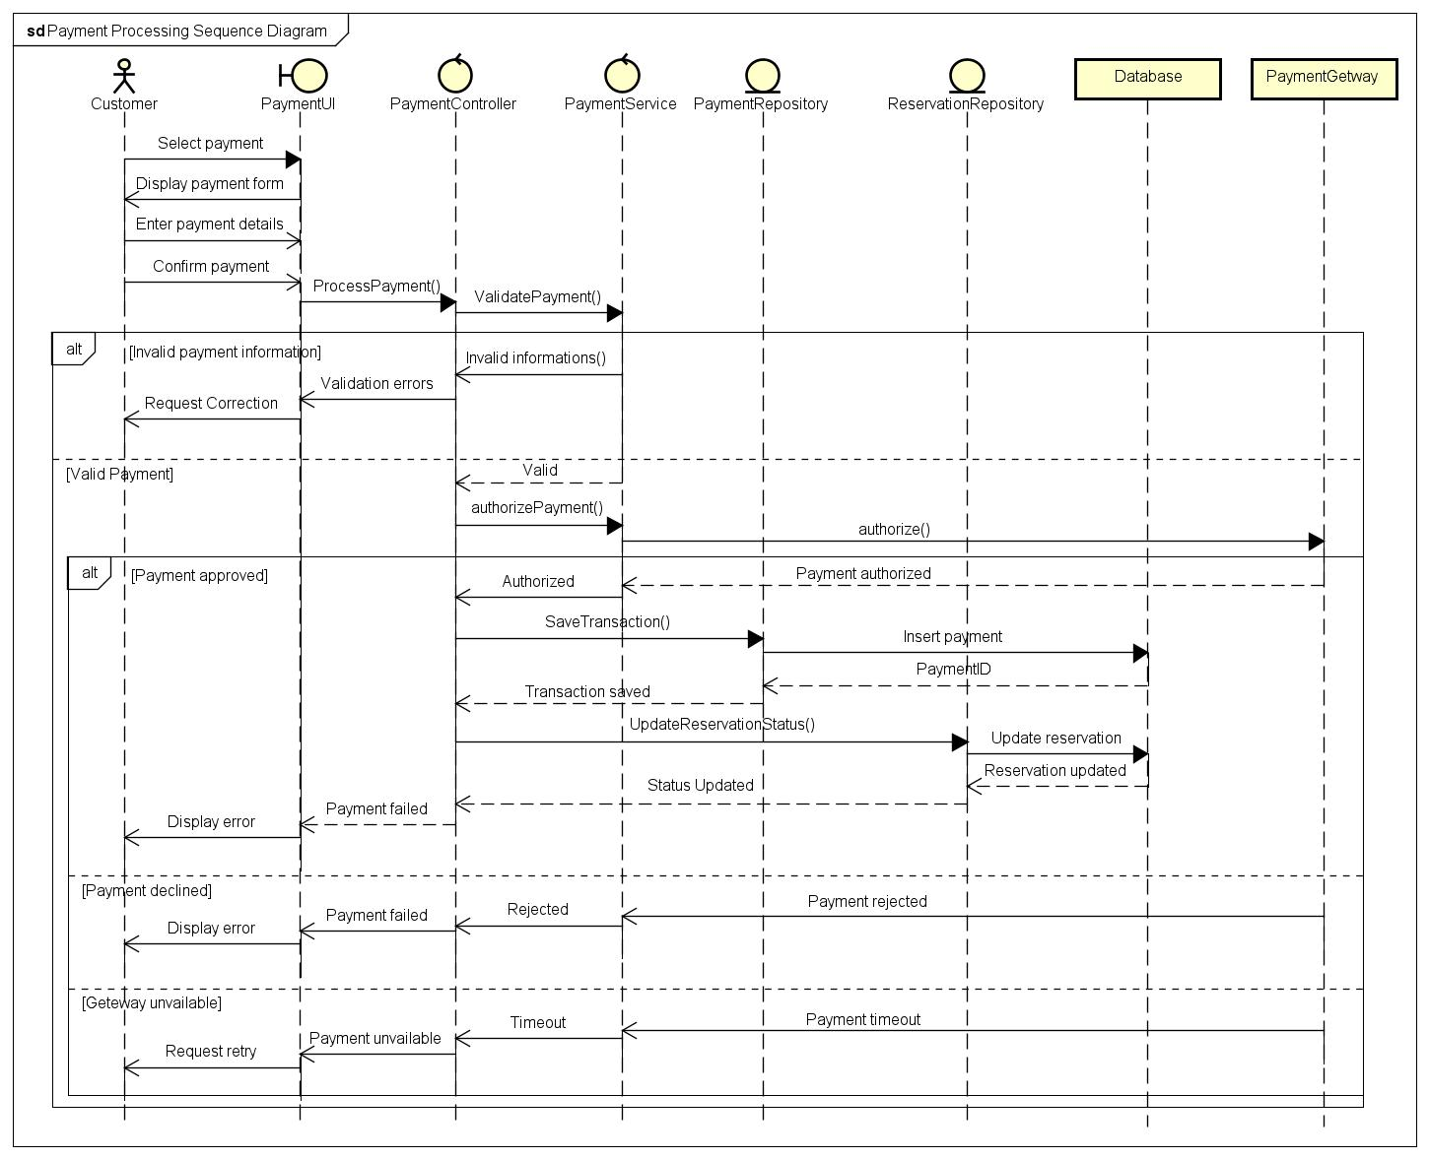
Figure 4 - Payment Processing Sequence Diagram

Fleet Management Sequence
Purpose
The Fleet Management Sequence Diagram serves the purpose of demonstrating the working of the rental agency as well as the system modules that manage the fleet of vehicles on the KriGo system. This model explains the steps involved in the process of inserting new vehicles, updating vehicle information and deleting them.
This sequence diagram also shows the validation of vehicle information, processing of requests for fleet management, vehicle information saving process and ensuring the correctness of fleet data.
Participating Objects
The sequence diagram involves the following participants:
- Rental Agency (Actor): Manages the fleet by adding, updating, deleting, and maintaining vehicle information.
- FleetManagementUI (Boundary): Provides the interface through which the rental agency performs fleet management operations.
- FleetController (Control): Coordinates fleet management activities and executes business logic.
- ValidationService (Control): Validates vehicle information before it is processed.
- VehicleRepository (Entity): Handles the storage and retrieval of vehicle records.
- Database (Database): Stores vehicle information and availability status.
Vehicle Registration Process
To add a new vehicle to the fleet management process, the rental agency chooses the Add Vehicle option in the FleetManagementUI. A vehicle registration form pops up and the agency fills in with necessary information such as vehicle model, make, registration identification number, rental amount per day, vehicle type, etc.
If the entered information is complete and valid, the data is sent to the VehicleRepository component for storage.
As soon as the vehicle information is stored successfully, the request is confirmed by the system.
Vehicle Information Update
The sequence diagram depicts the updating of existing vehicle information as well. When a rental agency selects a vehicle for updating, the FleetManagementUI will submit data to the FleetController.
The FleetController processes the request and provides instructions to the VehicleRepository to change the vehicle information in the database. The completion of the update will result in confirmation of the process by the system.
Vehicle Deletion Process
The Fleet Management Sequence Diagram discusses the deletion of vehicle details from the system. When the rental company sends the request to delete a vehicle, the FleetController informs the VehicleRepository about the request for deletion.
The repository deletes the vehicle details and confirms the deletion has been done. The system finally informs the rental company that the vehicle has been deleted from the fleet. This ensures that vehicles not available for rental are not shown to the customers anymore.
Vehicle Availability Management
The diagram also demonstrates how rent-a-car companies handle vehicle availability. When the status of a vehicle changes: due to maintenance or returning after the end of a rental period, for example, the rent-a-car company needs to update the vehicle's status in the FleetManagementUI. The system will process the request through the FleetController and ask the VehicleRepository to change the corresponding record in the database. After the update is completed but not before, the system sends confirmation to the rent-a-car company.
Data Validation
Prior to the implementation of any fleet management activity, the ValidationService conducts validation of the given vehicle information. There exist various validation procedures including checking for required fields, checking vehicle identification and pricing information, as well as verification of other business rules specified by the system.
In case of failure of the validation process the system will notify the rental agency about the validation errors encountered.
Alternative and Exceptional Flows
The Fleet Management Sequence Diagram includes several alternative execution paths to ensure reliable system behavior:
- Invalid or incomplete vehicle information.
- Successful vehicle registration.
- Successful vehicle information update.
- Successful vehicle deletion.
- Successful vehicle availability update.
These alternative flows guarantee that only valid vehicle information is stored while maintaining consistency within the fleet database.

Conclusion
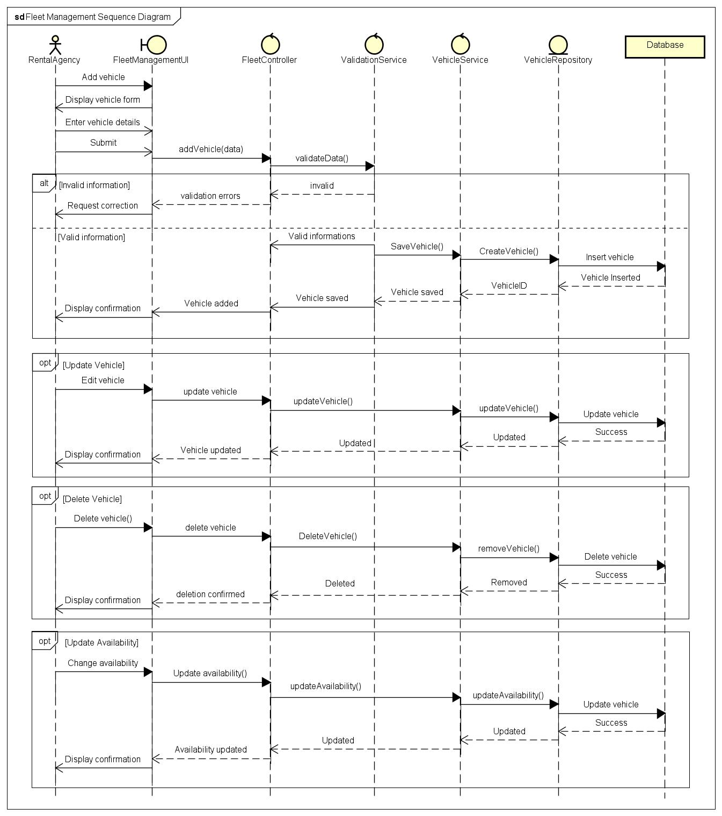
The Fleet Management Sequence Diagram offers a detailed view of the functions involved in the management of vehicles within the KriGo system. It shows the interaction of the presentation layer, business logic layer, validation services layer, and data persistence layer during the process of vehicle registration, vehicle information update, and vehicle information deletion and availability management. This diagram is a vital design artifact to understand how the fleet management subsystem works and how the system can keep track of the vehicles' data.
Figure 5 - Fleet Management Sequence Diagram

Branch & Employee Management Sequence
Purpose
The Branch & Employee Management Sequence Diagram depicts the interactions between the system administrator and the system components that manage branches and employees on the KriGo platform. This diagram shows the flow of operations to create new branches, register employees, update branch and employee information, and delete employee information.
The sequence diagram illustrates the process that the system uses to authenticate administrative data, manage requests, save organizational data, and preserve the integrity of branch and employee data.
Participating Objects
The sequence diagram includes the following participants:
- System Administrator (Actor): Responsible for managing branch and employee information.
- ManagementUI (Boundary): Provides the interface for performing branch and employee management operations.
- ManagementController (Control): Coordinates administrative workflows and applies business rules.
- ValidationService (Control): Validates the information entered before processing any operation.
- BranchRepository (Entity): Handles the storage and retrieval of branch information.
- EmployeeRepository (Entity): Manages employee records within the system.
- Database (Database): Stores branch and employee data.
Branch Registration Process
A new branch is created when the system administrator selects the option of creating a new branch. ManagementUI shows a form for branch registration. Administrator fills the required fields like branch name, address, contact details and other relevant information.
Upon submission of the form the ManagementController invokes the ValidationService to check if the data entered is complete and correct.
If the validation is OK, the controller forwards the request to the BranchRepository that saves the new branch information to the database.
The system confirms that the branch has been created and displays a message to the administrator confirming that the operation was successful.
Employee Registration Process
Also, the sequence diagram shows the process of adding a new employee. The operation is started by the system administrator through the ManagementUI by entering the employee’s information including personal details, branch assigned, role and contact information.
The ManagementController processes the request and delegates the persistence operation to the EmployeeRepository which persists the employee record to the database. When the employee information is saved successfully, the system informs the administrator that the registration process has been completed.
With this feature, administrators can easily manage employees that work for different rental branches.
Branch and Employee Information Update
The sequence diagram illustrates how the existing branch and employee data is updated. When administrator changes branch/employee record, this changed information is sent to ManagementController.
The controller then calls either the BranchRepository or the EmployeeRepository depending on which type of record is being updated, to update the relevant information in the database.
If the update operation is successful, the changes are confirmed and a suitable notification is displayed.
This feature enables administrators to keep information about the organization and personnel accurate.
Employee Removal Process
The sequence diagram also includes deleting employee records. The ManagementController receives the deletion request for an employee from the administrator and forwards it to the EmployeeRepository.
The repository removes the employee record from the database and sends back a confirmation that the operation has been successfully done. Then the system notifies the administrator that the employee has been deleted.
This helps ensure employee records are up to date and accurately reflect the composition of the organization’s workforce.
Data Validation
The information submitted is checked by ValidationService prior to conducting operations concerning branch or employee management to assure that it is compliant with the business rules established in the system.
Validation is the process which includes verification of required fields, verification of data format, as well as verification of completeness and consistency of the data.
If validation fails, the operation is terminated, validation errors are displayed by the system, and the administrator is notified to correct the errors before making a new request.
Alternative and Exceptional Flows
The Branch & Employee Management Sequence Diagram incorporates several alternative scenarios to ensure reliable system behavior:
- Invalid or incomplete branch information.
- Invalid or incomplete employee information.
- Successful branch registration.
- Successful employee registration.
- Successful update of branch or employee information.
- Successful removal of an employee record.
These alternative flows ensure that only valid administrative data is stored while maintaining the consistency and integrity of organizational information.

Conclusion
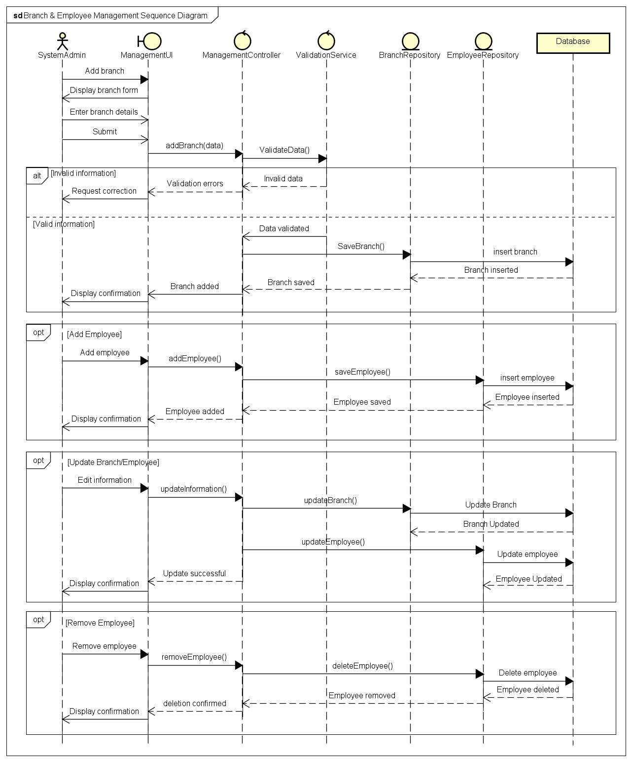
The process of branch and employee management is depicted in the Branch & Employee Management Sequence Diagram. The diagram shows the interaction among the presentation layer, business logic layer, validation services, and data persistence layer in the context of conducting various branch and employee activities, such as registration, management, update of information, and dismissal of personnel. This serves as a remarkable documentation for the purpose of grasping the concept of the administrative subsystem of the platform.
Figure 6 - Branch & Employee Management Sequence Diagram

Agency Verification Sequence
Purpose
The Agency Verification Sequence Diagram shows the flow of actions among rental agencies, administrators, and system parts during the agency validation stage of the KriGo platform. This stage serves to allow only legitimate rental agencies to provide car rentals through the KriGo system.
The sequence diagram represents the steps of submitting documents for verification, verifying the data provided in an application, review activities performed by the administrators, decision making, and the notification of the verification results.
Participating Objects
The sequence diagram includes the following participants:
- Rental Agency (Actor): Submits verification documents and receives the verification decision.
- Administrator (Actor): Reviews agency applications and approves or rejects verification requests.
- VerificationUI (Boundary): Provides the interface for submitting and reviewing verification requests.
- VerificationController (Control): Coordinates the verification workflow and business logic.
- ValidationService (Control): Validates submitted agency information and supporting documents.
- AgencyRepository (Entity): Stores and retrieves agency verification data.
- NotificationService (Control): Sends approval or rejection notifications to agencies.
- Database (Database): Stores agency applications and verification status.
Agency Verification Process
When a rental agency submits its registration and supporting documents, the verification process starts. The VerificationController uses the ValidationService to check whether enough information and documents have been provided.
The database is updated via the AgencyRepository with the valid application. The system notifies that its verification request has been submitted successfully and waits for the review of the administration.
Next, the system administrator takes the application from the queue, checks the received information and documents, and makes final decision about the agency's approval.
If the decision is positive, the verification status of the agency is changed by the VerificationController. The NotificationService is prompted to notify the agency of its successful verification. In case of denial of the application, the system registers this fact and sends a message that explains that the verification request was refused.

Document Validation
Prior to the submission of an application for administrative review, the ValidationService assesses the adequacy of the information provided and all documents provided in support of the application package. This includes the processes of checking required fields and ensuring that all documentation has been produced.
In the case of validation failure, the relevant errors are communicated to the system allowing the agency to rectify the application.
Alternative and Exceptional Flows
The Agency Verification Sequence Diagram includes several alternative execution paths:
- Invalid or incomplete verification documents.
- Successful agency verification and approval.
- Agency verification rejection following administrative review.
These alternative scenarios ensure that only valid applications are processed while maintaining the integrity of the agency verification process.

Conclusion
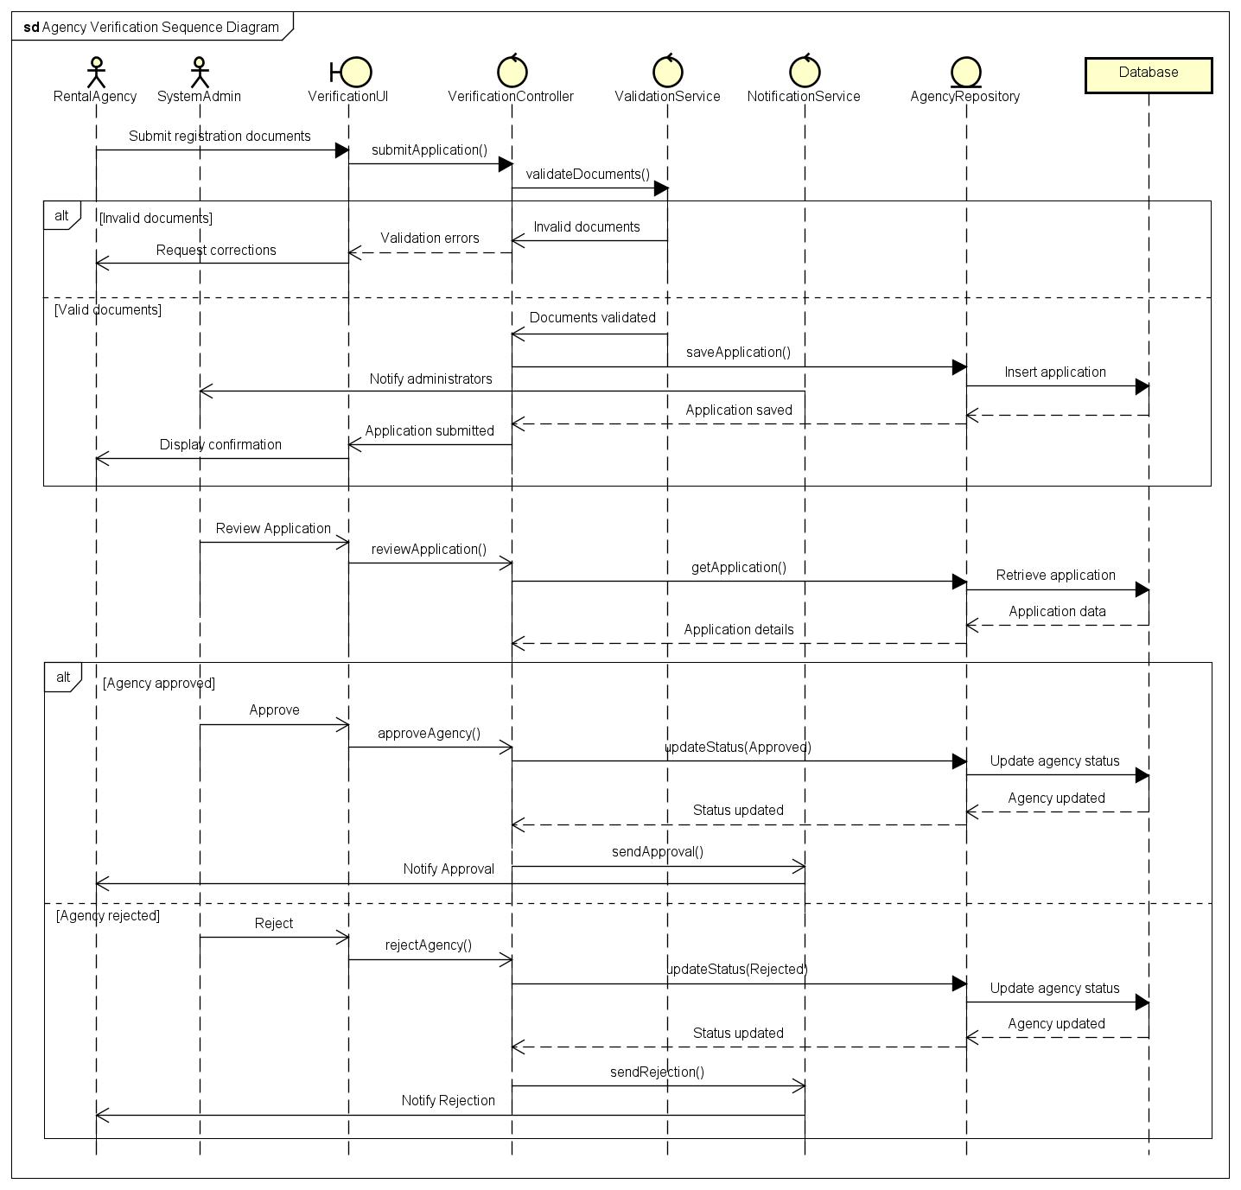
The Agency Verification Sequence Diagram encompasses a detailed view of the process of agency verification in KriGo. Timely indication of the role of each layer of the system architecture that assists in the process of agency verification on KriGo. The sequence diagram indicates the stages involved in certain interactions that take place between the presentation layer, business logic layer, validation services, and the notification service.
Figure 7 - Agency Verification Sequence Diagram

Dispute Resolution Sequence
Purpose
The diagram of dispute resolution displays how interactions are made between users, administrators, and various components of the system throughout the entire process of dispute management in the KriGo platform. It describes the process of submitting disputes, verifying information provided, processing disputes, assessing administrative actions taken, and notifying the parties involved about the decisions made.
The diagram allows for data to be processed in a transparent, systematic, and consistent way.
Participating Objects
The sequence diagram includes the following participants:
- Customer / Rental Agency (Actor): Initiates a dispute regarding a reservation, payment, vehicle condition, or another rental-related issue.
- Administrator (Actor): Reviews submitted disputes, investigates the case, and determines the final resolution.
- DisputeUI (Boundary): Provides the interface for submitting, reviewing, and managing disputes.
- DisputeController (Control): Coordinates the dispute resolution workflow and applies business rules.
- ValidationService (Control): Validates the dispute information before it is processed.
- DisputeRepository (Entity): Stores and retrieves dispute records.
- NotificationService (Control): Sends notifications regarding the dispute status and final decision.
- Database (Database): Stores dispute information and resolution records.
Dispute Submission Process
The procedure for dispute resolution starts with a customer or rental company lodging the dispute via the Dispute User Interface (UI). This submitted information generally contains reservation ID, description of the issue that needs resolution, and other related proof.
The Dispute Controller requests services of the ValidationService, which ascertains the completeness of the submitted data. After confirming that the data received is complete, the Dispute Controller utilizes services of the Dispute Repository and sends the data for its storage in the database.
Dispute Investigation
Subsequent to submission, the administrator checks the list of disputes awaiting resolution and chooses a particular dispute for investigation. The DisputeController accesses the data related to the dispute from the DisputeRepository, which gets the necessary information from the database.
The administrator goes through the complaint and verifies the evidence in order to arrive at the correct decision, adhering to the rules of the platform and considering the available evidence.
Dispute Resolution
When a dispute is found valid by the administrator, an entry is made in the database indicating that the dispute has been resolved. The NotificationService proceeds to inform both the customer and the company about the resolution.
In case the dispute is not valid; the administrator rejects the claim, and updates the status. The system registers the status update in addition to notifying both parties about the rejection.
Data Validation
Prior to the acceptance of a dispute, the ValidationService carries out a verification process of the supplied details for completeness and accuracy.
Validation involves the checking of obligatory fields, verifying that the relevant transaction or reservation exists, and checking that there is adequate information available to deal with the dispute.
Alternative and Exceptional Flows
The Dispute Resolution Sequence Diagram incorporates several alternative scenarios:
- Invalid or incomplete dispute information.
- Successful dispute submission.
- Administrative approval and dispute resolution.
- Administrative rejection of the dispute.
These alternative flows ensure that disputes are processed consistently while maintaining the integrity of dispute records and providing clear communication to all parties.

Conclusion
The Dispute Resolution Sequence Diagram offers a detailed overview of the dispute management workflow throughout the KriGo system. This diagram reflects the interactions amongst the presentation layer, business logic layer, validation services, data storage layer and notification services that provide assistance with respect to submitting disputes, investigating disputed cases, resolving conflicts, and rejecting disputes.
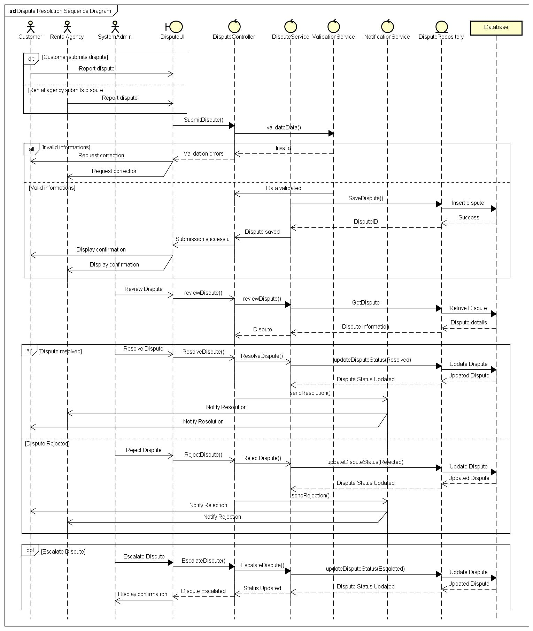
Figure 8 - Dispute Resolution Sequence Diagram

Recommendation Generation (AI) Sequence
Purpose
Recommendation Generation (AI) Sequence Diagram shows how the interactions between the client, recommendation sub-system and data repositories take place while generating personalized recommendations of the vehicles in the KriGo platform. The idea behind this process is to help clients find the best suitable vehicles as per their preferences and activities, and availability through an AI-driven recommendation engine.
The sequence diagram represents the process of extracting the client’s details, gathering data about the available vehicles, recommendation engine execution and generating personal recommendations.
Participating Objects
The sequence diagram includes the following participants:
- Customer (Actor): Requests personalized vehicle recommendations.
- RecommendationUI (Boundary): Provides the interface for requesting and displaying recommendations.
- RecommendationController (Control): Coordinates the recommendation workflow and business logic.
- RecommendationService (AI Engine) (Control): Executes the recommendation algorithm to generate personalized suggestions.
- CustomerRepository (Entity): Retrieves customer profile information and reservation history.
- VehicleRepository (Entity): Retrieves information about available vehicles.
- Database (Database): Stores customer profiles, reservation history, and vehicle information.
Recommendation Generation Process
The recommendation process is triggered once the customer asks for recommendations about suitable cars by using the RecommendationUI. RecommendationController fetches customer profile details, preferences, and past reservations from the CustomerRepository.
RecommendationController now fetches the list of available vehicles from VehicleRepository. Details about customers and vehicles are sent to RecommendationService (AI Engine) for processing the details and producing a list of recommendations based on user preferences, past reservations, search behavior, features of vehicle, and availability.
Recommendations produced by the AI engine are provided back to the RecommendationController and finally sent to the RecommendationUI.

Personalized Recommendation Logic
The AI recommendation engine evaluates multiple factors to improve recommendation quality, including:
- Customer preferences and profile information.
- Previous reservation and search history.
- Vehicle category and specifications.
- Rental price range.
- Vehicle availability.
- Similar user behavior and recommendation patterns.
By combining these factors, the recommendation engine provides suggestions that are more relevant to each individual customer.
Recommendations for New Customers
There is an alternative sequence for the case in which there is little or no prior history of interaction for the clients in the sequence diagram. In cases where there is no history to work on, such that the RecommendationService cannot provide personalized suggestions based on the history, it will provide a list of popular or well-rated cars.
No Matching Recommendations
The diagram also includes examples where the recommendation engine cannot find cars that match the customer’s requirements or constraints. In such cases, the RecommendationService returns an empty data set and suggests the customer change his search parameters or add some other car types to his requirements.
Alternative and Exceptional Flows
The Recommendation Generation Sequence Diagram incorporates several alternative scenarios:
- Successful generation of personalized recommendations.
- Recommendations for new customers based on popular vehicles.
- No matching recommendations due to unavailable or incompatible vehicles.
These alternative flows ensure that customers receive useful guidance regardless of their interaction history or current vehicle availability.

Conclusion
The Recommendation Generation (AI) Sequence Diagram is a detailed visual representation of the interactions associated with generating intelligent recommendations from vehicles through the KriGo platform. It shows how customer information, available vehicles, and intelligent recommendation engines work together to create the recommendations. This sequence diagram serves as an important design document that helps explain the recommendation subsystem of the platform.
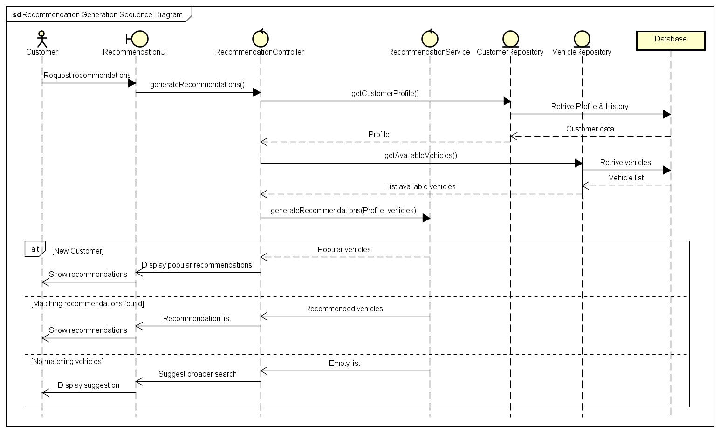
Figure 9 - Recommendation Generation Sequence Diagram

AI Assistant Interaction Sequence
Purpose
The AI Assistant Interaction Sequence Diagram shows the interaction pattern between the customer and the AI assistant present in the KriGo platform. The AI assistant helps out by answering queries and providing relevant details regarding reservations and vehicles. The interaction between the UI, AI processing, knowledge service, and data storage is shown through the sequence diagram.
Participating Objects
The sequence diagram includes the following participants:
- Customer (Actor): Initiates conversations with the AI assistant by asking questions or requesting assistance.
- AIChatUI (Boundary): Provides the conversational interface through which users interact with the AI assistant.
- AIController (Control): Manages communication between the user interface and the AI assistant service.
- AIAssistantService (LLM) (Control): Processes user prompts, retrieves relevant information, and generates natural language responses.
- KnowledgeService (Control): Supplies platform documentation, policies, and other contextual information required to answer general inquiries.
- ReservationRepository (Entity): Retrieves reservation information when users request reservation-related assistance.
- VehicleRepository (Entity): Retrieves vehicle information for availability and specification inquiries.
- Database (Database): Stores reservation, vehicle, and platform-related data.
AI Assistant Interaction Process
The process begins when the user sends a question to the system through the AIChatUI. The request is then forwarded by the AIController to the AIAssistantService for analysis of the request to find out the type of information that is required. For any general questions about the platform, the AI bot obtains context from the KnowledgeService before sending a reply.
Reservation Inquiry
If the user question involves an already made reservation, the AI assistant requests the relevant information regarding the reservation from the ReservationRepository. This repository then fetches the required information from the database and provides it to the AI assistant so that a customized response can be created accordingly.

Vehicle Inquiry
In case the customer is looking for details about any of the available cars, vehicle details, or renting, then the AI assistant fetches that particular information from the VehicleRepository. The repository accesses the database for the required vehicle information.
Handling Unknown Requests
The sequence diagram has also incorporated the concept of an alternate situation where the AI assistant cannot come up with a conclusive answer to the request from the user. In such cases, the AI assistant informs the AI controller about the fact that there is a need for additional help. The system then suggests contacting customer care or any other suitable facility.
Alternative and Exceptional Flows
The AI Assistant Interaction Sequence Diagram includes several alternative scenarios:
- General platform inquiries answered using platform knowledge.
- Reservation-related inquiries requiring reservation data retrieval.
- Vehicle-related inquiries requiring vehicle information retrieval.
- Unknown or unsupported requests that are redirected to customer support.
These alternative flows enable the AI assistant to provide flexible, context-aware support while ensuring reliable handling of requests beyond its capabilities.

Conclusion
The AI Assistant Interaction Sequence Diagram gives an all-encompassing view of how the conversational support mechanism works on the KriGo platform. It shows how the different parts work together in order to provide intelligent and personal assistance. This diagram plays a vital role as a design artifact in explaining how the AI assistant subsystem works.
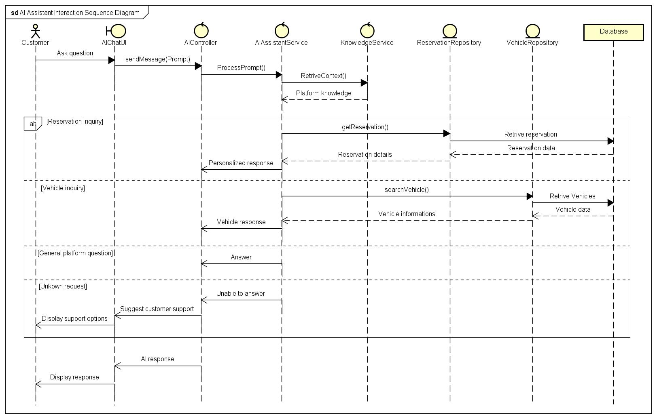
Figure 10 - AI Assistant Interaction Sequence Diagram

Analytics Insight Generation Sequence
Purpose
Analytics Insight Generation Sequence Diagram illustrates the interaction between the system administrator and the analytics subsystem that is responsible for creating the operational insights in the KriGo system. This diagram describes the process of collecting the data from various repositories, analyzing the data, creating useful insights out of them, and displaying the output through the analytics dashboard.
Participating Objects
The sequence diagram includes the following participants:
- System Administrator (Actor): Requests analytical reports and reviews generated insights.
- AnalyticsUI (Boundary): Provides the interface for requesting reports, applying filters, and viewing dashboards.
- AnalyticsController (Control): Coordinates the analytics workflow and manages communication between system components.
- AnalyticsService (Control): Processes collected data and generates statistical analyses, reports, and performance insights.
- ReservationRepository (Entity): Supplies reservation-related data.
- PaymentRepository (Entity): Supplies payment and revenue information.
- VehicleRepository (Entity): Supplies fleet and vehicle utilization data.
- Database (Database): Stores reservation, payment, and vehicle records.
Analytics Generation Process
It all begins with a request being made for an analytics report by the system administrator using the Analytics UI. This request is managed by the Analytics Controller by gathering relevant data about operations from Reservation Repository, Payment Repository, and Vehicle Repository. These repositories then perform queries on the database to provide datasets to the controller. After this, the Analytics Controller sends the collected data to the Analytics Service, where it performs various analyses and creates insights such as reservations trends, income summaries, vehicle usage statistics, and many more. Finally, the insights are delivered to the Analytics Controller and displayed on the Analytics UI.
Data Analysis
The AnalyticsService processes data collected from multiple operational areas to produce meaningful business insights. Examples of generated analytics include:
- Reservation statistics and booking trends.
- Revenue and payment summaries.
- Vehicle utilization and availability rates.
- Fleet performance indicators.
- Overall platform activity metrics.
These insights assist administrators in monitoring system performance and supporting operational and strategic decisions.

Filtered Analytics
Furthermore, the sequence diagram also captures the process of applying filter options on the analytics report. This is done by defining criteria, such as date range, vehicle types, branches, or any other reporting criteria. This request is then forwarded by the AnalyticsController to the AnalyticsService, and the new insights related to the selected criteria are returned.
No Data Available
The diagram includes an alternative scenario in which insufficient data exists to generate meaningful analytics. In this case, the AnalyticsService returns an empty dataset, and the system informs the administrator that no analytics are available for the selected criteria.
Alternative and Exceptional Flows
The Analytics Insight Generation Sequence Diagram incorporates several alternative execution paths:
- Successful generation of analytics insights.
- Generation of filtered reports based on administrator-selected criteria.
- No available data for the requested reporting period or filters.
These alternative scenarios ensure that the analytics subsystem remains reliable while providing informative feedback under varying data conditions.

Conclusion
The Analytics Insight Generation Sequence Diagram provides a detailed overview of the process of analytics generation within the KriGo system. The diagram demonstrates the manner in which the operational data is gathered, processed, and transformed into insights using the collaborative effort of the presentation layer, business logic layer, and data repositories. The provided diagram represents an important design document for the understanding of the analytics subsystem of the platform.

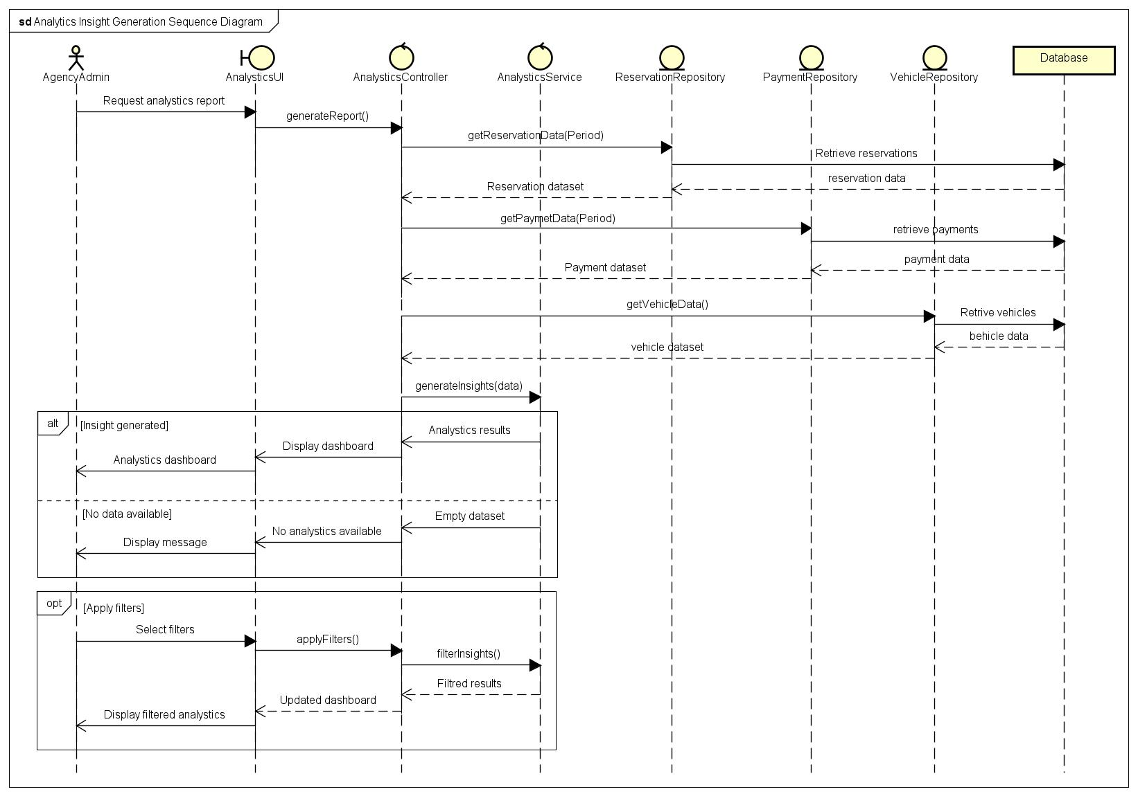
Figure 11 - Analytics Insight Generation Sequence Diagram

Quick Booking Sequence
Purpose
The Quick Booking Sequence Diagram shows the communication process involved in making a car booking using the mobile application through its quick booking process. The quick booking process allows users to make a booking for an available car in less user interaction time, hence shorter booking time overall.
Participating Objects
- Customer (Actor)
- MobileAppUI (Boundary)
- BookingController (Control)
- AvailabilityService (Control)
- ReservationRepository (Entity)
- Database (Database)
Process Description
A choice is made from the list of vehicles and Quick Booking function activated using the mobile app. This Booking Controller makes an inquiry to the Availability Service about whether the selected car is available in the given rental period. Once it turns out that it is available, then it becomes possible to create a reservation of the vehicle through Reservation Repository. Afterward, the customer gets a notification of his/her booking. On the contrary, if the vehicle is not available, the customer is notified about it.
Conclusion
The Quick Booking Sequence Diagram below shows how the mobile app makes the process of booking easy and secure for the client through availability checking and managing bookings.
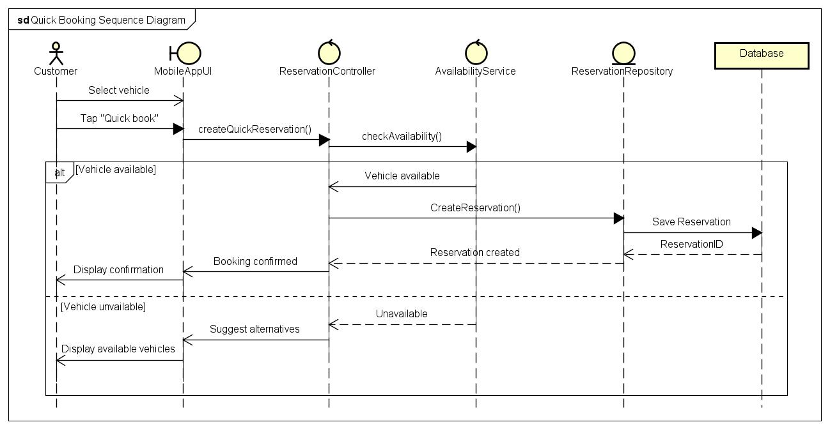
Figure 12 - Quick Booking Sequence Diagram

Location Services Sequence
Purpose
The Location Services Sequence Diagram illustrates how the mobile application retrieves the customer's location and displays nearby rental vehicles using GPS and mapping services.
Participating Objects
- Customer
- MobileAppUI
- LocationController
- GPS Service
- Map Service
- VehicleRepository
- Database
Process Description
The customer requests nearby vehicles via the mobile application. The system identifies the location of the customer with the help of GPS services provided by the device and accesses nearby vehicles in the database. Map Service provides the locations of the vehicle on a map, which helps the customer to find the nearby rental vehicles easily.
Conclusion
Location Services Sequence Diagram shows how location technologies improve the experience of the customer by providing nearby available vehicles.
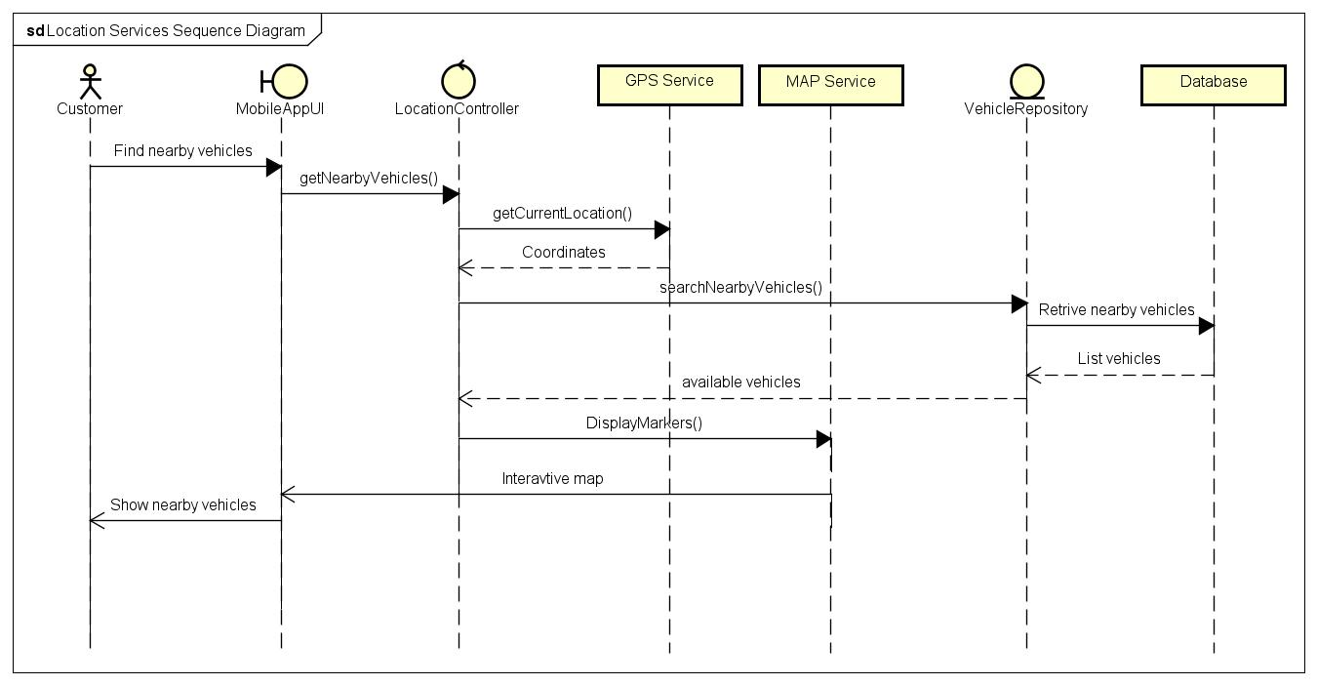
Figure 13 - Location Services Sequence Diagram

Push Notification Sequence
Purpose
The sequence diagram of push notifications depicts the process through which the KriGo platform pushes notifications to its customers in case of any changes related to reservations and payments.
Participating Objects
- Customer
- MobileApp
- NotificationService
- Firebase Cloud Messaging
- System
Process Description
Upon an event that needs to be notified to the user, the system triggers a notification to the Notification Service, which passes it on to the Firebase Cloud Messaging, which in turn pushes it to the customer’s mobile phone. The mobile app notifies the customer of the message.
Conclusion
Push Notification Sequence Diagram is a depiction of real-time messaging that ensures the customer is updated on any event.
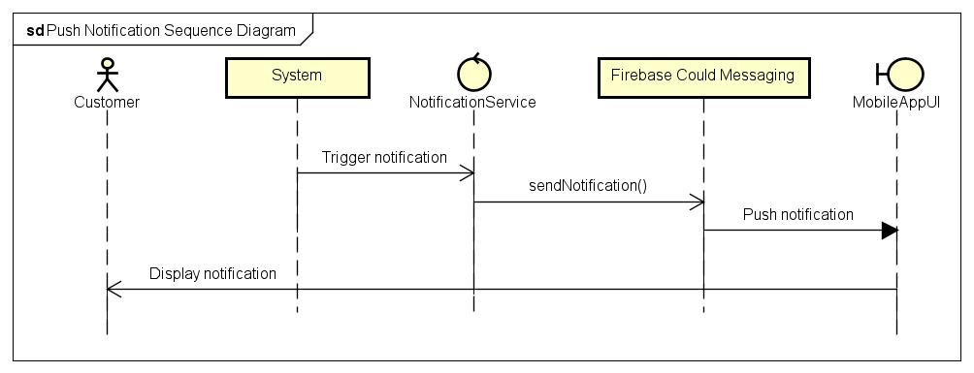
Figure 14 - Push Notification Sequence Diagram

Offline Synchronization Sequence
Purpose
Offline Synchronization Sequence Diagram is created to show how the mobile app makes it possible for the user to use specific features despite lack of connection and how the app makes sure that the data is synchronized in case the connection appears.
Participating Objects
- Customer
- MobileApp
- SyncController
- Local Storage
- SynchronizationService
- Database
Process Description
In case of using supported operations by the customer offline, the mobile app stores all the data locally. Then, when the connection appears, the SyncController gets all the changes from the device and passes them to the SynchronizationService. The service synchronizes the data with the central database and confirms its synchronization. Local data is synchronized too.
Conclusion
Offline Synchronization Sequence Diagram shows how the mobile application stays usable during network outages, and ensures synchronization of data kept locally to the main system once there is network connection again.

